43.45: The mass defect is 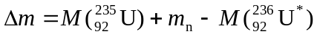
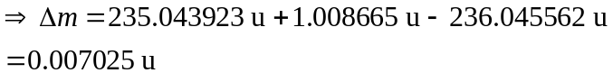
So the internal excitation of the nucleus is: 